Project Design Phase-II
Data Flow Diagram & User Stories

Date | 15 February 2026
Team ID | LTVIP2026TMIDS81736
Project Name | LearnHub: Your Center for Skill Enhancement
Maximum Marks | 4 Marks

Data Flow Diagrams:
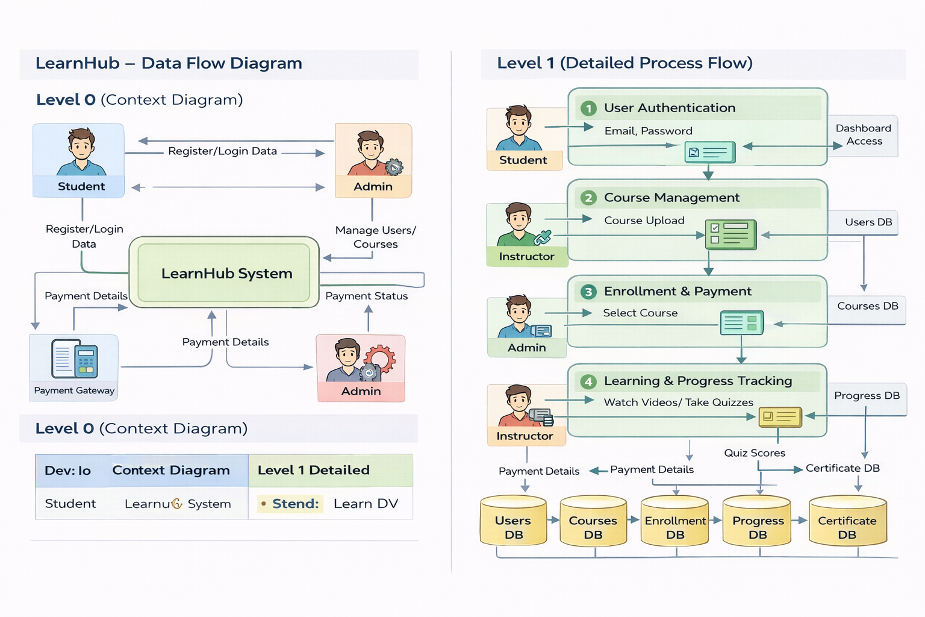

User Stories
User Type | Functional Requirement (Epic) | User Story Number | User Story / Task | Acceptance criteria | Priority | Release
Student (Web User) | Registration | USN-1 |  | Account created & dashboard accessible | High | Sprint-1
  As a student, I can register using email and password
Student (Web User) | Authentication | USN-2 | As a student, I can log in securely | Successful login redirects to dashboard | High | Sprint-1
Student (Web User) | Course Listing | USN-3 | As a student, I can view available courses | Course list loads from database | High | Sprint-1
Student (Web User) | Course Enrollment | USN-4 | As a student, I can enroll in a course with one click | Enrolled course visible in “My Courses” | High | Sprint-2
Student (Web User) | Payment | USN-5 | As a student, I can pay for premium courses | Payment success message displayed | Medium | Sprint-2
Instructor | Course Upload | USN-6 | As an instructor, I can upload courses and videos | Course visible in platform after upload | High | Sprint-3
Administrator | Course Approval | USN-7 | As an admin, I can approve instructor courses | Approved courses go live in system | High | Sprint-4
Student (Web User) | Progress Tracking | USN-8 | As a student, I can view my learning progress | Progress bar updates after lessons | Medium | Sprint-4
Student (Web User) | Certificate | USN-9 | As a student, I receive certificate after completion | Certificate available in dashboard | Medium | Sprint-5

